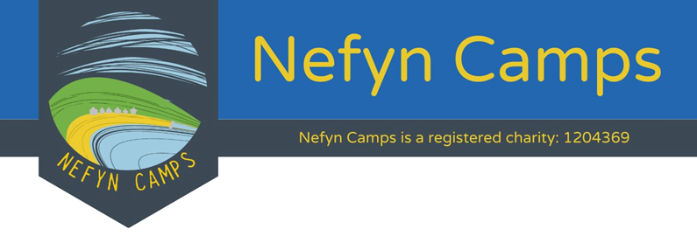
Bursery Form
Details of person making the request
Name
Role (e.g. Youth worker / Relative / Friend)
Phone
E-mail

Details of the young person attending camp
Name
Camp to attend
Cost of camp
Amount of subsidy applied for
Please explain (max 100 words) why they would benefit from a Nefyn Camp and what circumstances make it difficult for the family to afford the Camp fee.

Signed
Date
Guidance notes
Bursery process
- Please get the parent / guardian to complete the on-line application for camp. When it gets to the checkout stage, please click the ‘Pay later’ option.
- Please note that at this stage the application is not confirmed.
- Complete the bursary application and send the completed form to bookings@nefyncamps.co.uk and copy in the Camp leader.
- We will then confirm if your bursary application has been agreed.
- Pay the fees you’ve agreed to pay either via the booking system or bank transfer. This can either be in one payment or we can agree a payment plan.
- We’ll then process the application.
Completion of form
The form can be completed either: -
- Electronically and with your typed name counting as your signature. Or.
- Printing and completing by hand then sending a scanned copy.
Person making the request
This could be the parent / guardian of the young person attending camp, a youth worker, church pastor, friend etc.
Camp to attend
Select A/B/C/D/E so we can match with your application.
Amount of subsidy applied for
It is the policy of Nefyn Camps that the person attending should always make some contribution towards the camp fees (at least £40). We’re happy to agree a payment plan if this can’t be paid straight away.
Circumstances
Please briefly explain these (max 100 words). If we want more details, we’ll call / e-mail.

